Names : _______________________________________________________________________
News Report Disaster Project

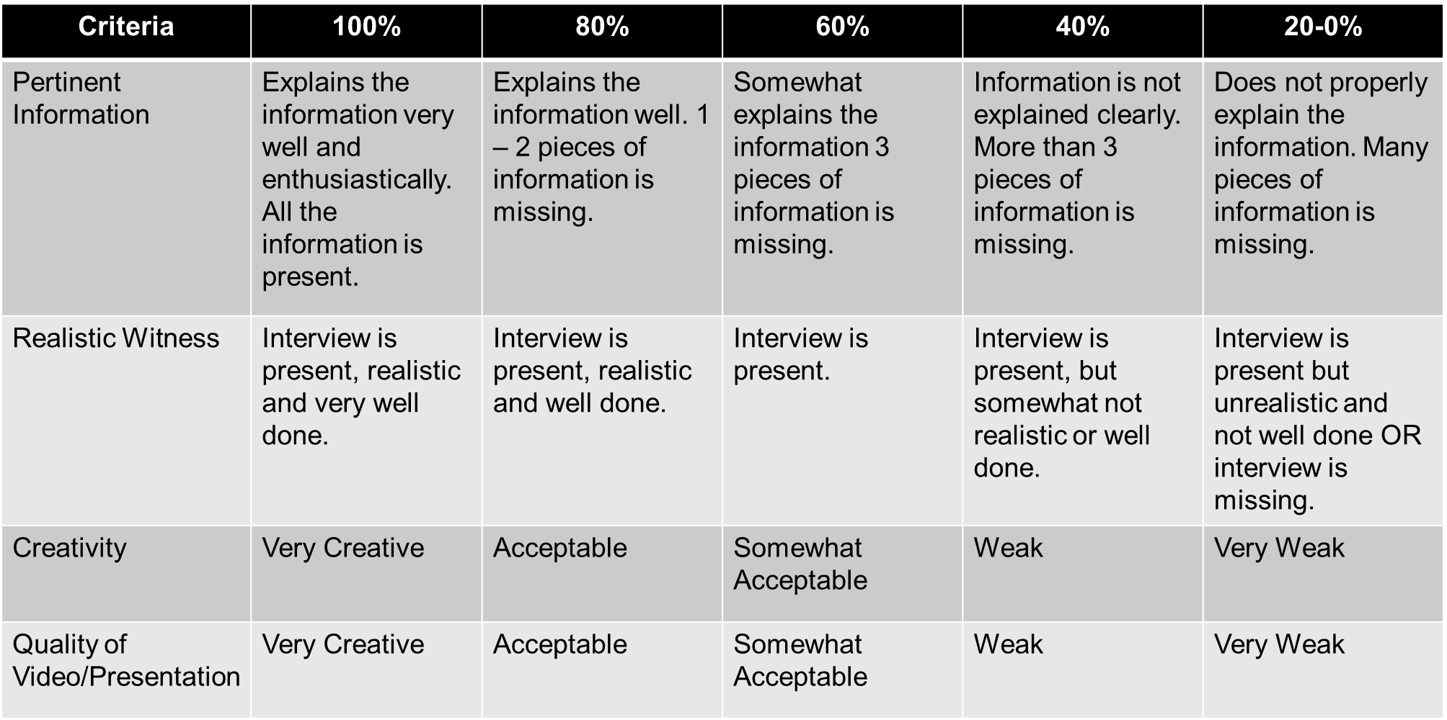

Info: Date of the disaster (month, date, year)
Info: Give a brief definition explanation of the disaster
Info: Short information about the country and the map
Info: Statistics (How many people died? What kind of damage is present?)
Info: Include video and pictures
Witness: What were they doing?
Witness: How did they feel?
Witness: What did they see?

Comments:

