Name: ________________________________________________________________________________
Group: ____________

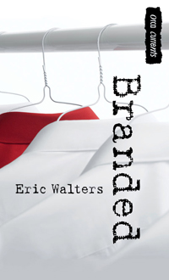

BRANDED READING STRATEGY GUIDE
DO NOT LOSE THIS DOCUMENT
Branded Reading Strategy
Study Guide

Branded by Eric Walters
Ian, Julia and Oswald find themselves at the centre of a storm of protest when their school decides to make students wear uniforms. Julia is opposed to the whole concept. Ian, doesn't really care one way or another, until he discovers the origin of these uniforms.
This novel explores an area taken from today’s news concerning sweat shops and child labor.
http://www.ericwalters.net/novels/branded/

The principal announces that the school is implementing uniforms, and Ian finds himself caught in a conflict. His friend Julia wants him to devise a plan to fight the decision, and the principal is determined to convince Ian the uniforms are a good idea. Ian wants nothing to do with the issue. While doing research for a social-justice class, he learns that the manufacturer of the uniforms is on the top-ten list for human-rights violations. When he tells the principal this, all he gets is a reminder that the penalty for refusing to wear the uniforms is suspension, and Ian finds himself caught in a whole new conflict--one with himself.
http://www.goodreads.com/book/show/7779013-branded

Before we read…
- What topics would we study if we were in a “Social Justice Class”?
Write your answers in the box.

- What are the pros and cons of wearing a uniform?

Pros | Cons

- In my opinion, I think uniforms are a ____________ idea because….
Write your answer in the box…
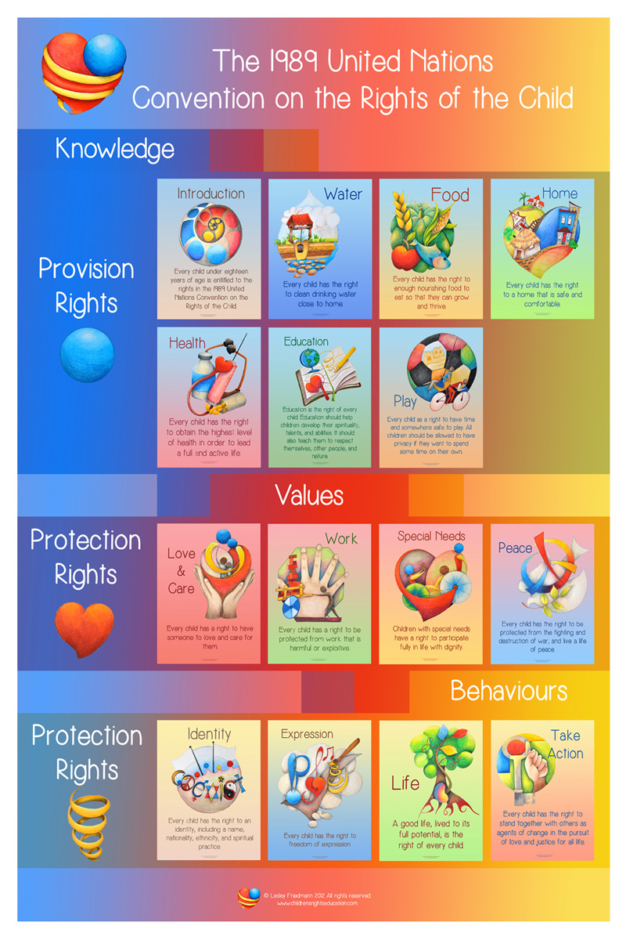
http://childrensrightseducation.com/un-convention-on-the-rights-of-the-child.html
- Look at the poster on the previous page.
  - What is the title?
  - What is it talking about?
  - What are the 3 main sections?
  - Under each main section, what are the sub-categories?
Title: ____________________________________________________________________________
 | SECTION | SUB-CATEGORIES

  - Put a star beside the category you think is the most important.
I think _______________________________________ is the most important category because:
Write your answer in the box…

Homework: Find out exactly where your uniforms come from.
Write your answer in the box…

READING STRATEGIES:
Be positive!

Focus on what you UNDERSTAND.

For example:

- Read page 1 and 2 in your novel.
- Hi-light everything you understand.
- Skip the words or expressions that you do not understand.
- Now, what do your pages look like? Are they all coloured up?
- See, you know more than you thought you knew!

Chapter 1
The story begins in a classroom.
The teacher is asking his students questions.
Answer the following questions in full sentences.

- List all the characters that are speaking in this chapter in the box below.

- Why did Julia get suspended?

- Highlight the point of view that is present in this novel:
  - First person point of view
  - Third person poin of view
  - Omniscient point of view

- Who is talking when the author writes “I”?

- Under what curcumstances does Mr. Roberts say it is okay to kill?

- What did The Social Justice class cause Ian to do?

- What did the Social Justice class often do?

- Why is Mr. Roberts teaching this class even though he’s not really a teacher?

- What new rules did Mr. Roberts implement?

- Why does Mr. Roberts want to speak to Oswald after class?

Extra:
Online Research:

- Mahtma Ghandi
- Martin Luther King Jr.

- Choose one of the two famous world leaders above.
- Go to the Internet.
- Find information about his life.
- Find images.

Who was this person?
Where and when did he live?
How did he make a difference in the world?
Name: ____________________________________________ born ___________ died __________
Write your answer in the box…

Branded : Chapter 2
- Where are Ian and Julia and why are they there?

- Julia and Ian both had the same idea about what?

- What sentence tells us what Mr.Roberts thinks about punctuality?

- What does it mean to “pilot a new project”?

- What two things will Mr. Roberts’ new change bring to the school?

- What changes do Ian and Julia think it will be?

- What is Mr. Roberts’ opinion about tattoos and why is this a contradiction?

- When did Oswald appear and how did everyone react when they saw him?
Why did they react this way?

- What will happen at the start of next semester?

- What is the “Student Coucil”?

Extra:
At the end of this chapter, Julia and Ian are heading to see Mr. Roberts in his office.
Create a dialogue between Julia and Ian as they head down the hallway towards his office.
Take into consideration what they might be thinking after the assembly in the auditorium.
Julia:
Ian:
Julia:
Ian:

Julia:
Ian:

Julia:
Ian:

Chapter 3
- What is a threat?

- What threat existed?

- Describe Mr. Roberts’ desk.

- What is Julia’s opinion of the change?

  - Explain why she feels this way.

- What is Ian’s opinion of the change?

- What is Mr. Roberts reasons for this change?

- What type of effect is the uniform having on Oswald?

- How does he feel wearing the new uniform?

- How does Oswald think the uniform will look on Ian?

- Explain why Julia is being sarcastic to Oswald.

Chapter 4: Literature Roles
Director: Think of two questions you would ask a friend who read Chapter 4.
- ______________________________________________________________________________________________________________________________
- ______________________________________________________________________________________________________________________________
Vocabulary: Find two words you do not understand. Look it up in the dictionary
and write one small sentence.
1) _________________
_______________________________________________________________
2) _________________
_______________________________________________________________
Summarizer: In 3 – 4 sentences, summarize Chapter 4.
Step 1. Read the chapter.
Step 2. Highlight the characters.
Step 3. Underline any important information/event.
Step 4. What are the characters talking about? Why is it important?
_____________________________________________________________________________________________________________________________________________________________________________________________________________________________________________________________________________________________________________________________________________________________________________________________________________________________________________________________________________________
Questioner:
- What promise does Julia make and who will it involve?

- What advice does Ian give Oswald?

- What is a bribe?

- What does Ian want to eliminate? Explain.

- What did Ian do to get school dances back again?

- What would get a couple of million views on YouTube really fast?

Chapter 5 + 6:

Read Chapter 5 + 6 and answer the GOOGLE document by the end of class. You can listen to music while answering the document.
Chapter 7 + 8:
Read Chapters 7 and 8. Think of four questions about Chapters 7 and 8 you might receive on a test.
1.

2.

3.

4.

Sweatshop Activity:
After playing the simulation game, answer the following questions:
a) How did you feel while playing this game?

b) What kind of relationship does the boss/employer have with his worker/employee?

c) Do you find this treatment fair?

d) What are some examples of how the worker/employee was mistreated?

e) List 5 examples of companies that have used sweatshops in order to make their
products.
1)
2)
3)
4)
5)

Chapter 9 + 10:
Read Chapters 9 and 10 and answer the following questions:
- What does Ian notice about his school uniforms?
- How does Ian prove to Oswald that what he discovered was true?

- What is Ian`s plan by the end of Chapter 10 ? How does Oswald feel?

Chapter 11 + 12 + 13:
Finish the novel and summarize in 4-5 sentences what happens.

________________________________________________________________________________________________________________________________________________________________________________________________________________________________________________________________________________________________________________________________________________________________________________________________________________________________________________________________________________________________________________________________________________________________________________________________________________________________________________________________________________________________________________________________________________________________________________________________________________________________________________________________________

Vocabulary Words:
For each chapter, write two words you do not understand. This must be done after EACH reading and WILL BE VERIFIED.

Chapter 1
Chapter 2
Chapter 3
Chapter 4
Chapter 5
Chapter 6
Chapter 7
Chapter 8
Chapter 9
Chapter 10
Chapter 11
Chapter 12
Chapter 13

