The Giant Project – Narrative Text
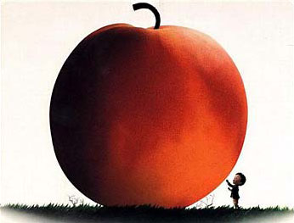

After reading « James and the Giant Peach », we read about the orphan named James who after accidentally dropping crocodile tongues, saw a peach grow into a giant fruit with many new friends living inside it.
It is now YOUR turn to tell a different yet similar story about a boy or girl that came across something magical and then witnessed a giant adventure and made new friends.

You need to include in your new story :
- 1 main character
- 3 secondary characters
- 2 settings (Where does your main character live? What is the giant object?)
- Giant object
You will need 3 paragraphs.
In your first paragraph you must include :
- Introduce the begining of the story
Once upon a time…
Introduce the main character – how old are they? Where do they live? How do they meet or find something magical?
How does the object grow into a giant?
- Continue with the middle
How does your character enter the giant object?
What happens when your main character enters the giant?
Describe the new characters that they meet (include descriptive vocabulary – at least 3 for each character)

- Finish the story
What problem do they come across?
How do they solve the problem?
How does your story end?
- Draw the cover page to your story and include a NEW title similar to « James and the Giant Peach » (ex. Bob and the Giant Whale)

NARRATIVE ORGANIZER

CRITERIA | EXAMPLE | YOUR IDEA
Main Character  What`s their name?  Where do they live?  How old are they? | James
Giant Object- with descriptions | Peach
(3) Secondary Characters – with descriptions | Centipede, Miss Spider, Earthworm
How did the object grow? | An old man gave James magical crocodile tongues
How did your main character enter the giant object? | A small door into the peach that became a tunnel and then finally met new friends.
What problem happened?  How do they solve the problem? | The peach rolled into the ocean. The peach was attacked by sharks. The peach flew into the air with the help of seagulls.
How does your story end? | The peach falls and lands on top of the Empire State Building
Rubric

